**WBS with Predecessors**

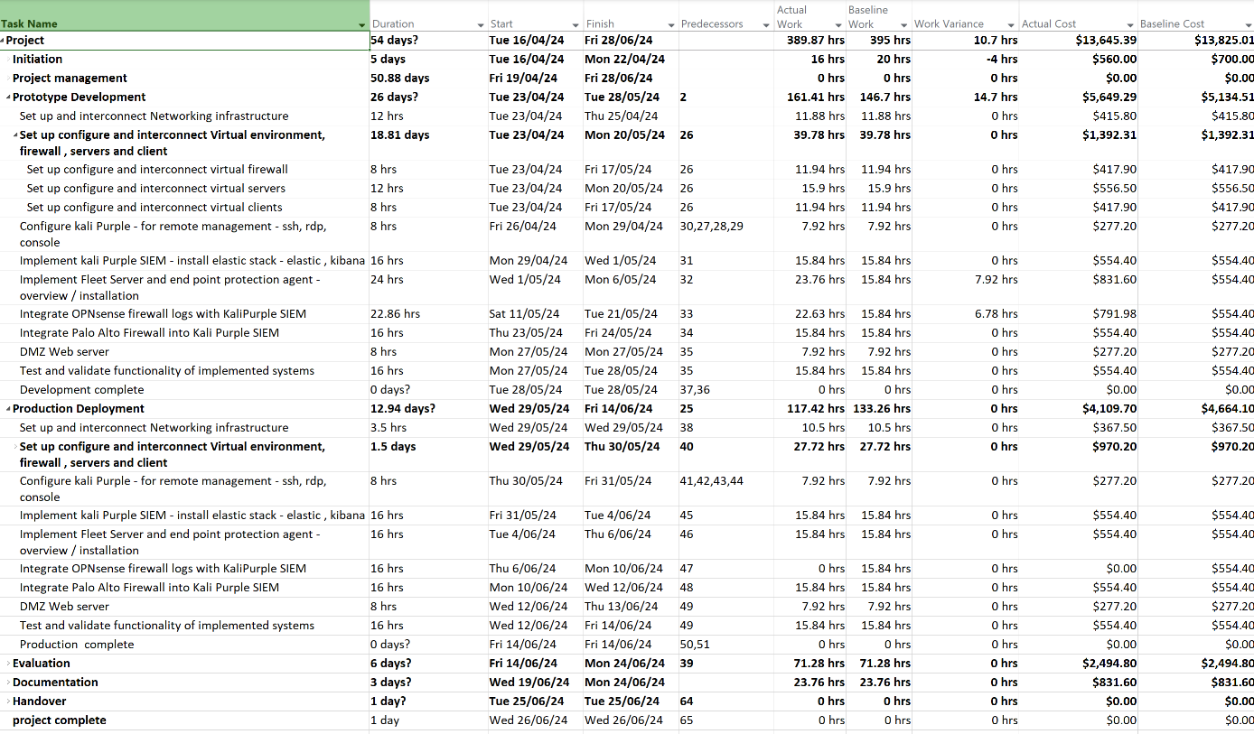

**Gantt Chart**

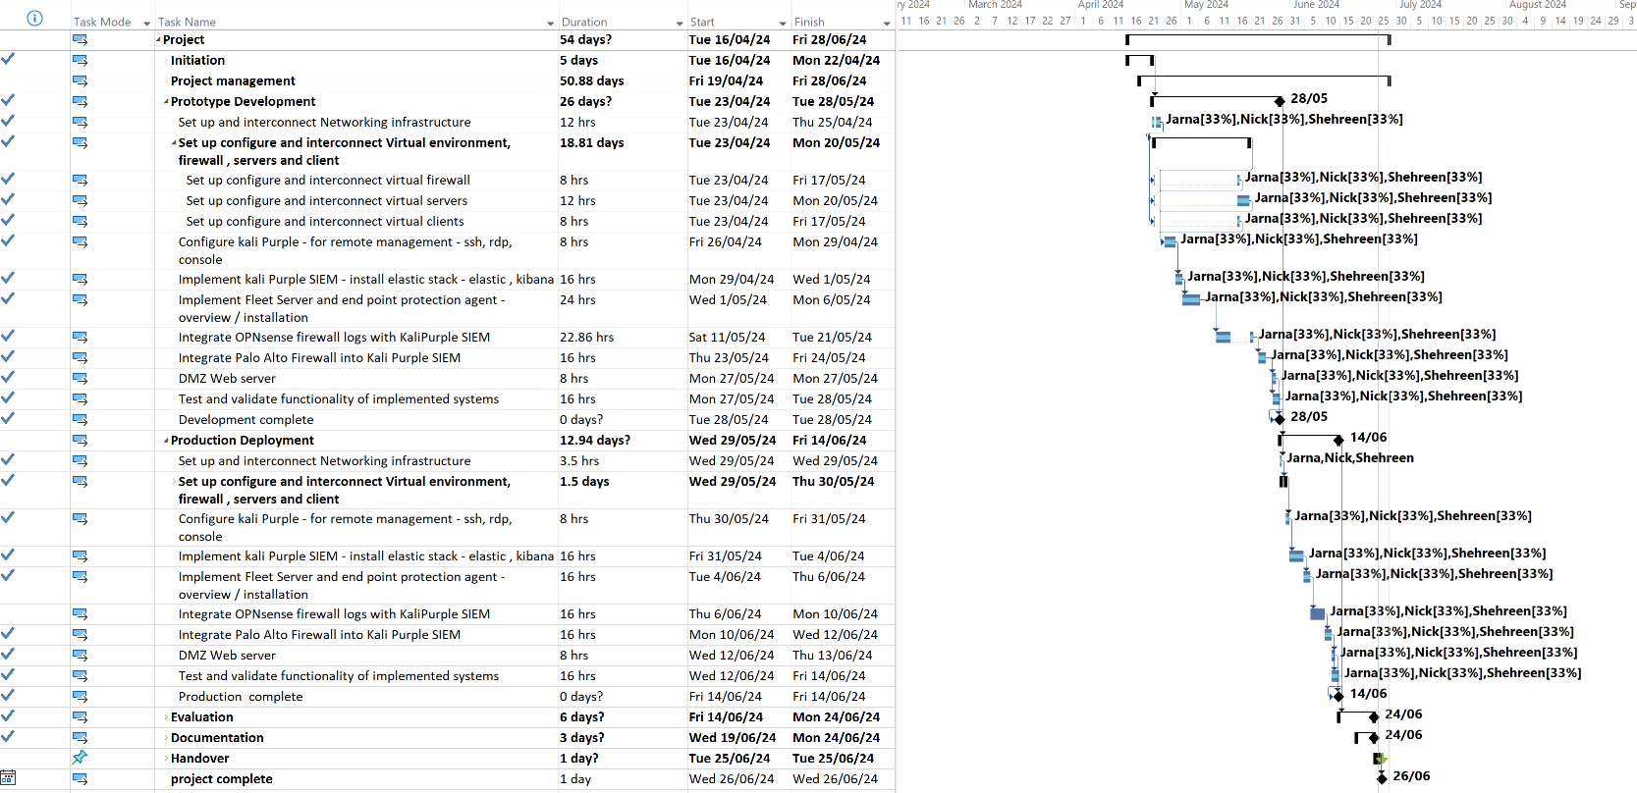

**Gantt Chart (With Actual vs Baseline Work)**

**Working time for each Task**

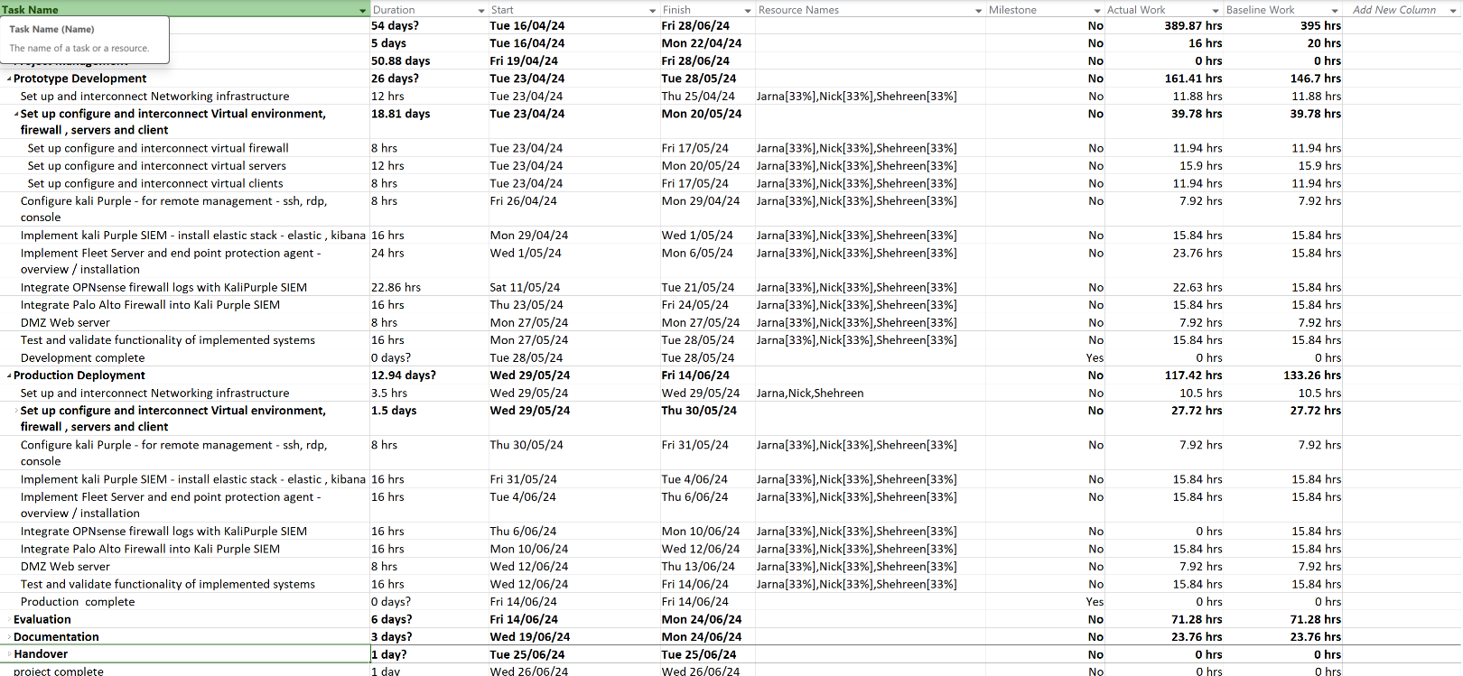

**Resources allocated to each task (Task were allocated evenly. Refer to Tasks in Trello for breakdown)**

**Task Costs**

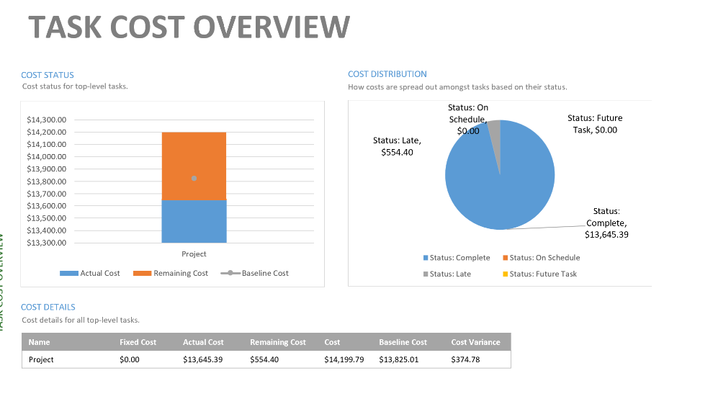

**Milestones Report**

**Costs**

